Data Cleaning and Data Wrangling
Data Quality Challenges
- Missing values
- Duplicates
- Invalid formats
Techniques
- Null Handling
- Duplicate Removal
- String Manipulation
  - trim()
  - lower()
  - upper()
  - regexp_replace()
Hands-on — Customer Data Cleansing Project
- Clean dataset
- Validation report
Spark SQL
- Temporary Views
- SQL Queries
- SQL Functions
  - Aggregate functions
  - Window functions
  - Date functions
Hands-on — Business Reporting Use Case
- Department-wise reports
- Salary analytics
- Trend reports
Working with Files and Data Sources
File Formats
- JSON
- Parquet
- ORC Files

Data Cleaning and Data Wrangling
Data Cleaning & Data Wrangling are important steps in data processing. Real-world datasets are rarely ready for analysis immediately. They may contain missing values, duplicate records, incorrect formats, spelling differences, unwanted characters, or insistent values.
The basic process in data analytics is:
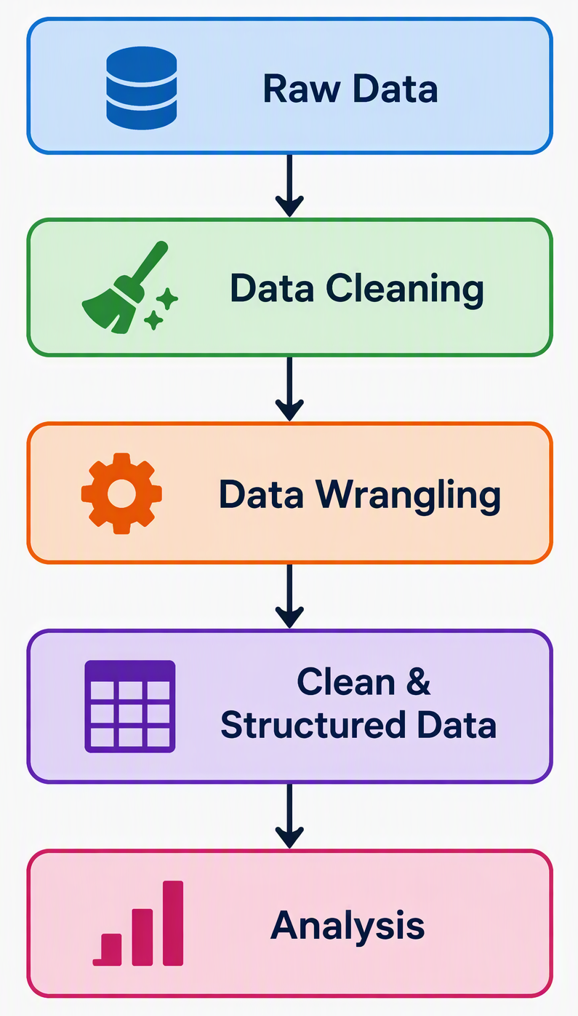
What is Data Cleaning?
It is the process of identifying & correcting or removing inaccurate, incomplete, duplicate, inconsistent, or improperly formatted data.
e.g.
Name | Age | City | Email
Amit | 25 | Pune | amit@email.com
Neha | Missing | Mumbai | neha@email.com
Amit | 25 | Pune | amit@email.com
Rahul | Twenty Eight | Delhi | Invalid Email
Priya | 28 | New  Delhi | priya@email.com

What is Data Wrangling?
It is the broader process of transforming the raw data into a structured & useful format for analysis.
It can include cleaning, filtering, combining datasets, changing data types, creating new columns, standardize value, reshaping data, & aggregating information.

e.g.
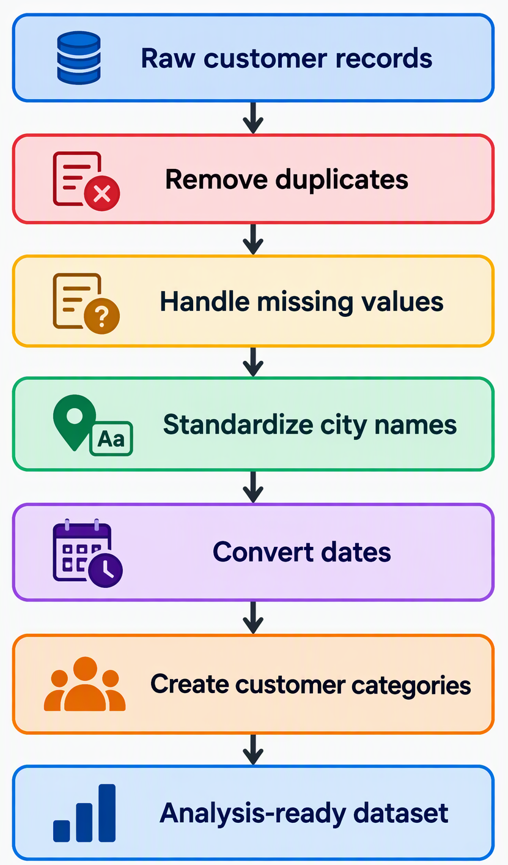
Data Quality Challenges
- Missing values
- Duplicates
- Invalid formats
Data Cleaning Techniques
- Null Handling
  - Remove Records
  - Replace Missing Values
  - Keep Null Values
- Duplicate Removal
  - If there is complete duplicate, keep only one row.
  - If there is duplication based on a key (like CutomerId), keep the most relevant row & delete all other rows.
- String Manipulation
  - trim() – Use it remove extra spaces(leading or trailing)
  - lower() – Convert case
  - upper() – Convert case
  - regexp_replace() – Replacing one or more continuous characters in a given string using regular expressions.

Overall data cleaning process
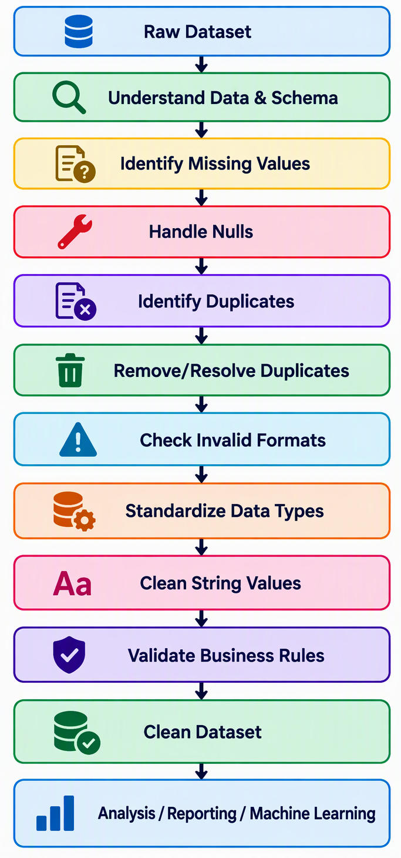
Hands-on — Customer Data Cleansing Project
- Clean dataset
- Validation report
Spark SQL
Spark SQL is a component of Apache Spark used to process structured & semi-structured data using SQL queries & the DataFrame API. It allows developers & data analysts to work with large distributed datasets using familiar SQL syntax.
Basic Flow of Spark SQL
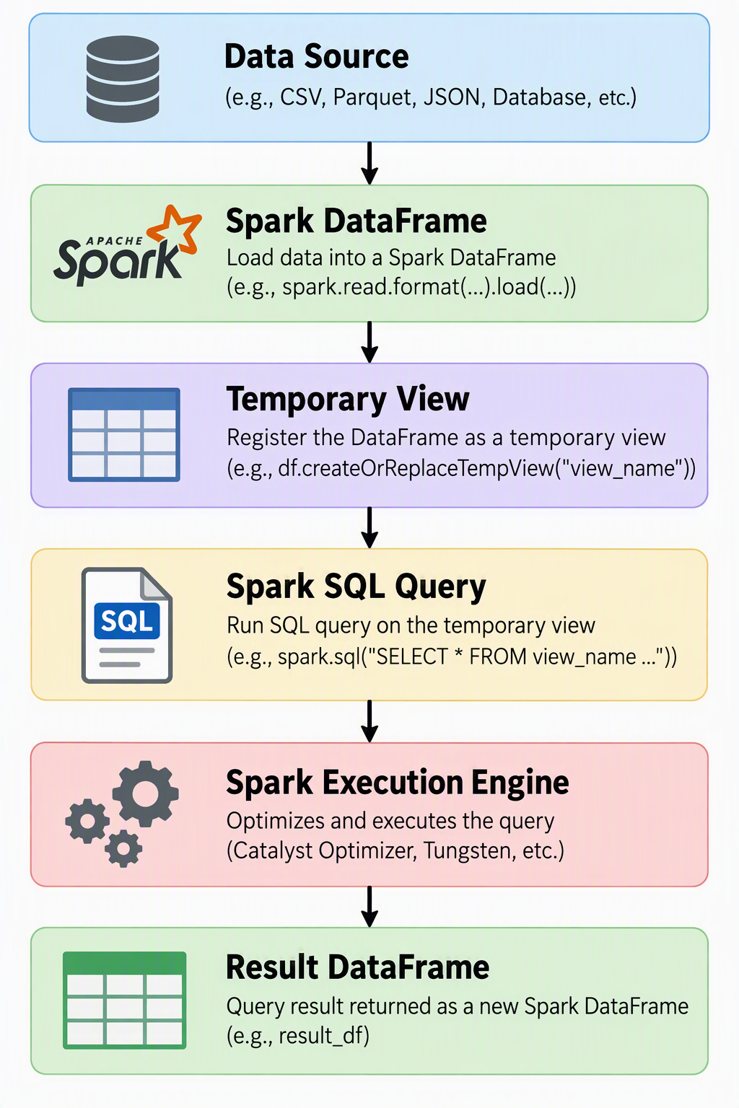
- Temporary Views
A Temporary View gives a Spark DataFrame a table-like name so that it can be queried using SQL.
Characteristics of Temporary Views
A temporary view is associated with the current SparkSession. It is not intended to be permanently stored database table. When the relevant SparkSession/application ends, the temporary view is lost.
Global Temporary Views
Spark also supports global temporary views. These can be accessed across SparkSessions within the same Spark application & are placed in a reserved database named “global_temp”.
- SQL Queries
Once a DataFrame is available as a view or table, Spark SQL can perform standard SQL-style operations.
  - SELECT – Used to retrieve required columns.
  - FROM – Used to reference the Temporary View.
  - WHERE – Used to filter records based on conditions.
  - ORDER BY – Used to sort the result.
  - GROUP BY – Used to organize records into groups before performing aggregation.
  - HAVING – Used to filter grouped results.
  - JOIN – Used to combine related information from multiple datasets.
    - Inner Join
    - Left Join
    - Right Join
    - Full Join
    - Left Semi Join
    - Right Semi Join
    - Left Anti Join
    - Right Anti Join
Assume we have following DataFrames:
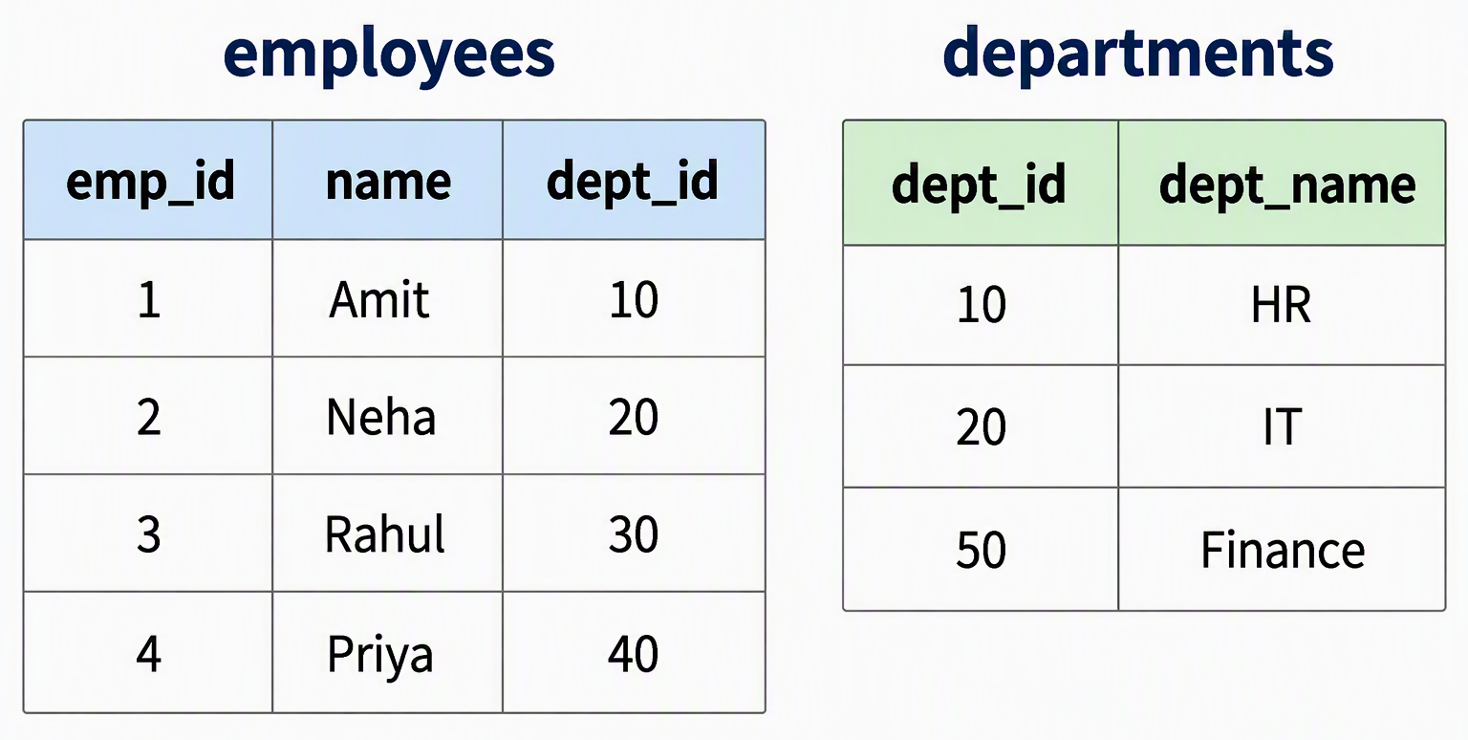
- Left Semi Join – It returns the rows from the left DataFrame that have a matching row in the right DataFrame.
- Right Semi Join - It returns the rows from the right DataFrame that have a matching row in the right DataFrame.
- Left Anti Join - It returns the rows from the left DataFrame that do not have a matching row in the right DataFrame.
- Right Anti Join - It returns the rows from the right DataFrame that do not have a matching row in the right DataFrame.

- SQL Functions
Spark SQL provides many built-in function for data processing. These are divided in important categories
  - Aggregate functions
    - COUNT
    - SUM
    - AVG
    - MIN
    - MAX
    - STDDEV
    - VARIANCE
    - COUNT(DISTINCT ---)
  - Window functions
    - ROW_NUMBER
    - RANK
    - DENSE_RANK
    - LAG
    - LEAD
  - Date functions
    - current_date
    - current_timestamp
    - year
    - month
    - day
    - dayofmonth
    - dayofweek
    - date_add
    - data_sub
    - datediff
    - add_months
    - months_between
    - to_date
    - to_timestamp()
    - date_format
    - last_day
Spark SQL Processing Flow
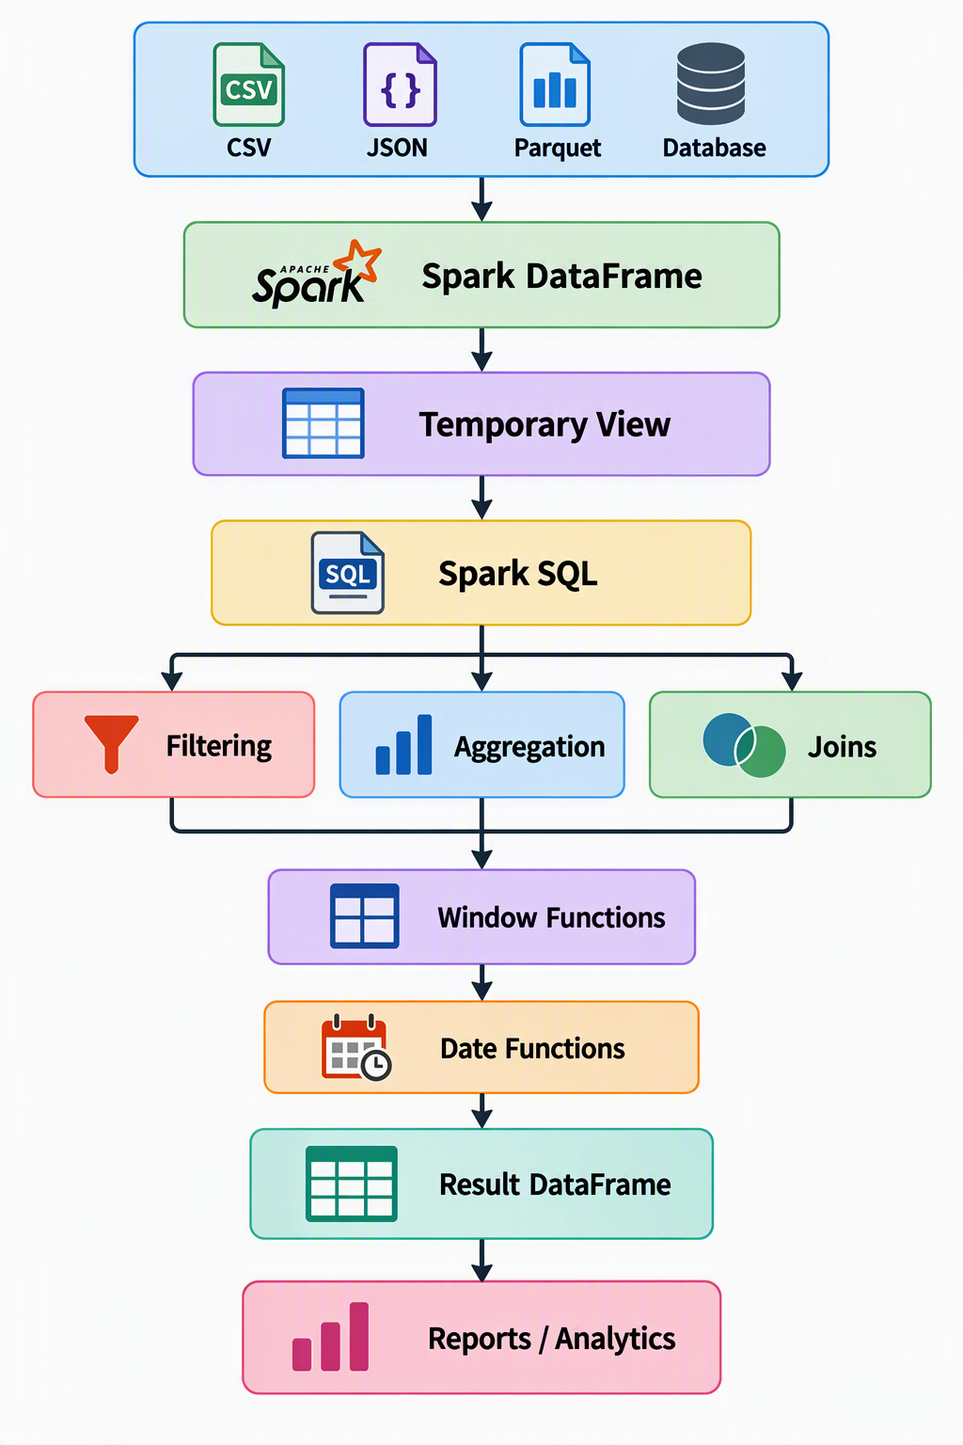
Hands-on — Business Reporting Use Case
- Department-wise reports
- Salary analytics
- Trend reports

